Anatomy Chart: Insulin and Glucose

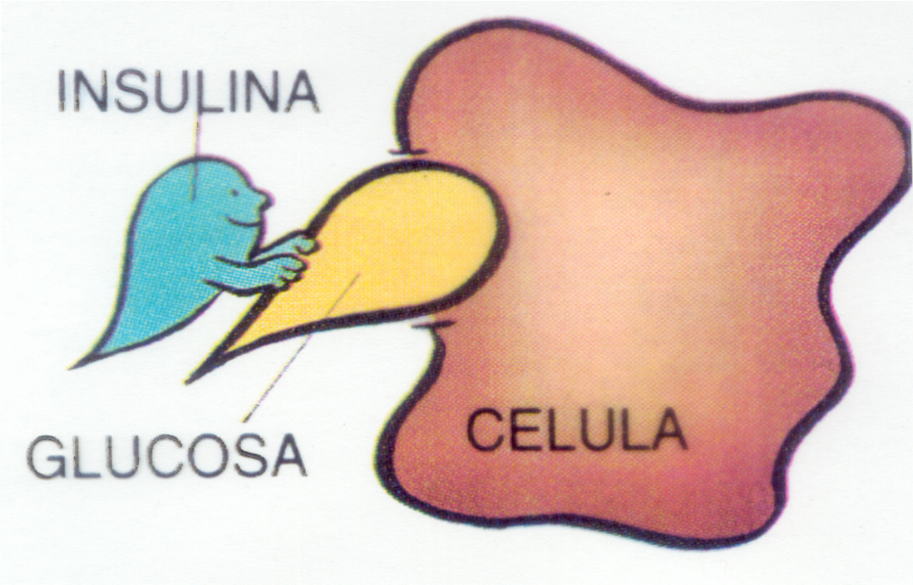
Insulin
Cell
Glucose

