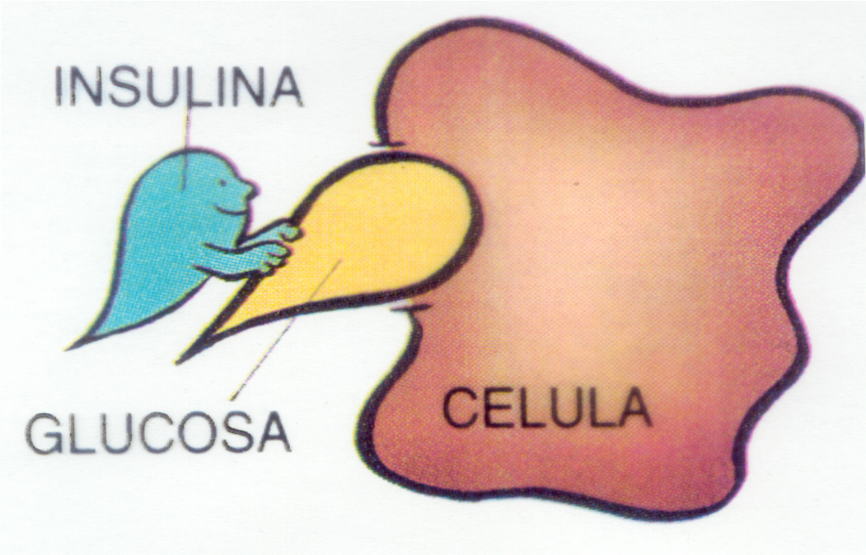
Anatomy Chart: Insulin and Glucose

