
Eat Well and Walk More to Prevent Diabetes

Your Name: _______________

Copyright © 2009 The Regents of the University of California, all rights reserved
See https://livewellbewell.ucsf.edu for complete citation
Table of Contents

Get Ready, Get Set: Prevent Diabetes.…………….…………………..…….…………..4
Plan Better Meals to Control Blood Sugar……………………….……………………23
Food Labels and Diabetes Prevention.....………………………………………………54
Get Active! .………62
Stress and Diabetes……………………………...…………………..……………………….82
Graduation and Strategies for Healthy Living.……………..……………………….90

Welcome to Live Well, Be Well!
Congratulations on joining the Live Well, Be Well program and making a commitment to health for yourself and your family. When you are at risk for diabetes, you have to make changes in your life to prevent diabetes. It’s not always easy to make changes. This program lets you decide what is most important to you. We will give you information, support, and encouragement. We will also teach you some skills to make the changes that are most important.

This binder gives you information about the Live Well, Be Well program, pre-diabetes, and diabetes. It also gives you ways you can lower your risk for diabetes.

Keep this binder, take it with you to workshops, add materials to it, but most of all use it.

Live Well, Be Well
City of Berkeley Division of Public Health
1947 Center Street, Second Floor
Berkeley, California 94704
Phone: 510-981-5367
Fax: 510-981-5395
TDD: 510-981-6903
How can I “Live Well and Be Well”?

We hear about healthy living everywhere, but what does it really mean? The good news is that is does not mean replacing your favorite foods with tofu, or spending all your time inside a gym or exercising.

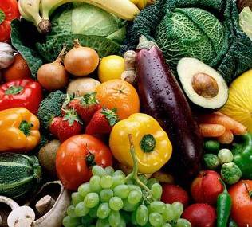
Healthy living means eating more fruits, vegetables, whole grains, and lean meats. It means eating fewer foods that have lots of fat and sugar. Healthy living also means doing some physical activity at least 5 times a week.

Are you feeling like you don’t know where to start? You can use this guide for ideas on eating healthier and adding more activity to your day. After that, you can talk with your health counselor to make a plan for better health habits. She will help you figure out things that make it hard for you to be healthy and things that make it easier. You might decide to eat one more serving of fruit each day, or take a short walk before dinner.
Whatever you decide, remember that small changes can make a big difference.
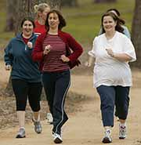

Let’s Get Started!

Get Ready, Get Set:
Prevent Diabetes
What is in Get Ready, Get Set
Prevent Diabetes?

Introducing Live Well, Be Well.………..………………………………..………………..6
Live Well, Be Well Group Meetings....………………………………………………..…8
Make Live Well, Be Well Work For You.....…………………………………………..10
The Basics about Diabetes .………11
Diabetes Myths …………………………………...…………………..………………………..13
Diabetes Risk Factors …..…………………………………………..………………………..15
4 Ways to Prevent Diabetes ….…...16
What Are You Eating? Using Your Food Diary ………………………………..…...18
Pedometer Basics ….……19
What is an Action Plan? ………….. ………20
My Action Plan .……..21
Web Resources ………………………………………………………………………..………..22

Introducing Live Well, Be Well!

Live Well, Be Well is a joint project of the Berkeley Public Health Department and the University of California San Francisco (UCSF). The health department offers the program. UCSF is evaluating it to find out if it can help people lower their blood sugar levels.

What happens in the Live Well, Be Well program?
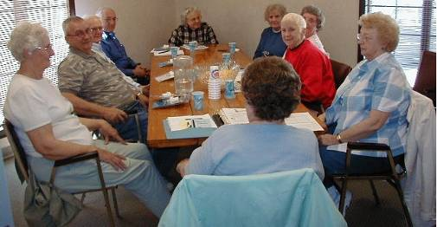
- You go to a Get Ready, Get Set meeting: This is the first meeting. It is an introduction to the Live Well, Be Well program. We will discuss myths about diabetes, diabetes, and pre-diabetes. You will learn 4 ways to prevent diabetes. You will also learn how to make Live Well, Be Well work for you. You will get some program materials including a pedometer that counts how many steps you walk. You will also get a food diary to keep track of what you eat.

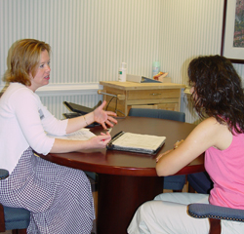
- You will meet with your health counselor to create your personal health program: You will meet one-on-one with a health counselor who will help you put together a program that works for you.


- You will get phone calls: Your health counselor will call you 10 times in the next 6 months. The calls will be scheduled at times that work for you. Your health counselor will help you:
  - Learn new ways to be active and eat better
  - Use support from family and friends to help you stay on track

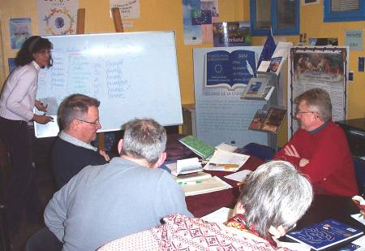
- You will go to group meetings: Every month, free meetings will be offered. You will meet others in the program and learn more about how to reduce your risk of getting diabetes. Topics will include exercise safety, reading nutrition labels, stress management, and more. We ask you to attend at least 3 of these meetings.


- Meet with UCSF staff for your 6 month and 12 month interviews.

During the program, the health counselor and program staff are expected to:
- Be available to you to answer any questions
- Give you support, motivation and any other tools that will help you stay with your personal program
- Help you design a personal program that works for you
Live Well, Be Well Group Meetings
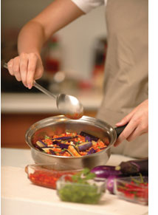

Plan Better Meals to Control Blood Sugar: Learn about eating healthy and portions sizes. We will also learn how whole-grains and fiber help prevent diabetes.

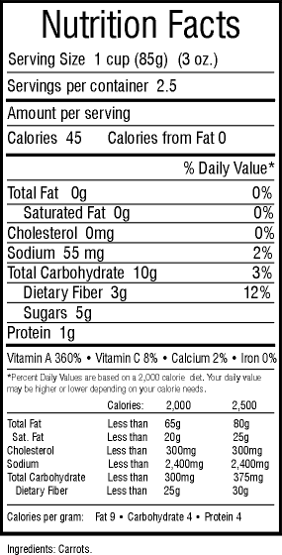

Food Labels and Diabetes Prevention: This meeting will help you understand food labels. We will discuss how fats and carbohydrates affect blood sugar.

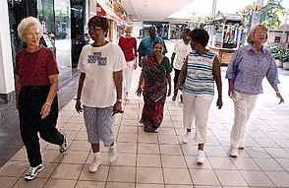
Get Active: We will talk about the benefits of physical activity on preventing diabetes. We will talk about ways to incorporate physical activity into your day, exercise safety, and go for a 30- minute group walk. Bring your walking shoes.

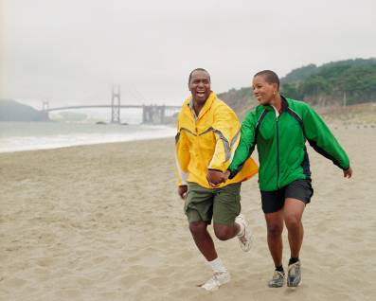
Stress and Diabetes: Learn how stress affects diabetes. Learn ways to reduce stress through movement, talking, self-expression and having fun.

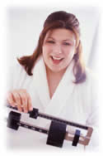

Graduation and Strategies for Healthy Living: Learn how to maintain your healthy habits by becoming your own health manager. Learn how to find the support you may need to continue living healthy.
Make Live Well, Be Well Work for You
Research shows that eating healthier and moving more will prevent diabetes in people who are at risk of diabetes. Start by thinking of goals that you can do that will help you reduce your risk of diabetes.

Write your answers to the following questions:
Why did I join the Live Well, Be Well program?
_________________________________________________
_________________________________________________

What do I hope to achieve by taking part in Live Well, Be Well?
_________________________________________________
_________________________________________________

How will healthy eating and being active help me and others?
_________________________________________________
_________________________________________________

I choose to change my life to reduce the chance that I will get diabetes. I will work with my counselor, my family, or my friends to get help with those changes.
__________________________
Your signature
The Basics about Diabetes

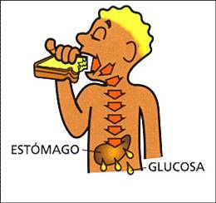
What Is Diabetes?
Stomach
Glucose
Diabetes is a serious disease in which the amount of blood sugar (glucose) is too high. The body uses sugar from the foods we eat for energy. With diabetes, the body cannot use the sugar. It stays in the blood stream and builds up to high levels. This is called high blood sugar or high blood glucose.
Diabetes if blood sugar is more than
125

Pre-Diabetes if blood sugar is 100 to 125

Normal if blood sugar is less than 100

What Is Pre-Diabetes?
Before people get diabetes they usually have ‘pre-diabetes’ or borderline diabetes. This is when your blood sugar is higher than normal, but not high enough to be called diabetes. This means there is a good chance of getting diabetes soon if you do not make healthy life changes. Often there are no symptoms and people do not know they have pre-diabetes.
Results are based on a blood draw from an arm


What Happens If I Get Diabetes?
High levels of sugar in the blood can damage nerves and blood vessels. This can lead to blindness, kidney disease, and nerve problems. It can also cause gum infections, heart disease, strokes, and amputations. Treatment and early detection can prevent this damage. You can control diabetes by getting more active and eating healthier.

What Can I Do To Prevent Diabetes?
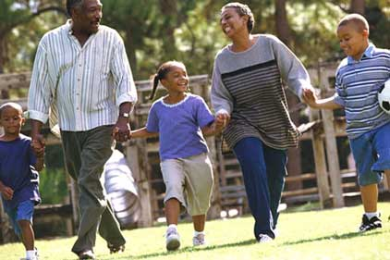
Diabetes can be prevented. People who are at risk for getting diabetes can prevent it by walking or exercising 30 minutes a day. It can also reduce risk by losing a little bit of weight and eating a healthy diet. Even small changes can have a big effect on your risk for getting diabetes.
Diabetes Myths

Here are some myths that you may have heard about diabetes:

Myth: Eating too much sugar causes diabetes.
Fact: When you eat food, the body turns food into blood sugar for energy. Blood sugar or glucose is not the same type of sugar you buy in the store. When the body’s own insulin does not work well or when not enough is made blood sugar levels rise.

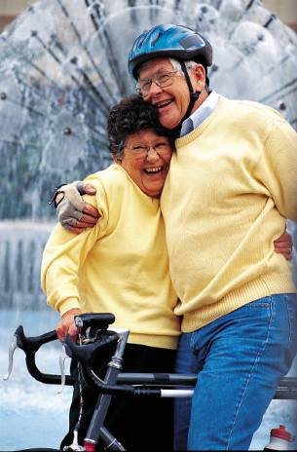
Myth: Exercises does not help people with diabetes.
Fact: Exercise helps the body to produce insulin, while at the same time keeps stress levels under control. Both of these help to keep blood sugar under control. People under stress may eat more and exercise less making blood sugar rise.

Myth: I will know that I have diabetes by my symptoms.
Fact: People with type 1 diabetes will have symptoms because they have little or no insulin. Type 1 diabetes is rarer and type 2 diabetes is more common. People with type 2 diabetes may have few or no symptoms since they are making some insulin. Either the body is not making enough insulin or it is not using it properly. Only a blood test can tell for sure if someone has diabetes.

Myth: I will not be able to eat starchy foods, like bread and potatoes.
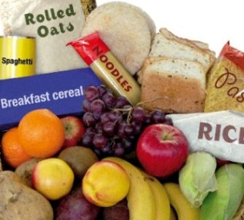
Fact: To control blood sugar, all sources of carbohydrates must be controlled. Carbohydrates include starchy foods like pasta and bread as well as candy. Even juice, milk, fruits and vegetables all contain carbohydrates. Carbohydrates are your main source of energy so you should not stop eating them, but instead eat them in smaller amounts.
Diabetes Risk Factors

There are risk factors that put us at risk for diabetes that we can not do anything about such as
- Having a parent, brother, or sister with diabetes
- Being African American, Latino, Alaskan Native, American Indian, Pacific Islander or South Asian
- Being over 40 years old
- Being a woman who had diabetes during pregnancy


The good news is that there are risk factors that put us at risk for diabetes that we can do something about such as
- Losing weight if you are overweight
- Increasing exercise each week, if you exercise a little or not at all
- Lowering and controlling cholesterol levels, if you have high cholesterol
- Lowering and controlling blood pressure, if you have high blood pressure

Of the risk factors that you can do something about, which one would you like to begin working on?
Write it down here: __________________________

4 Ways to Prevent Diabetes

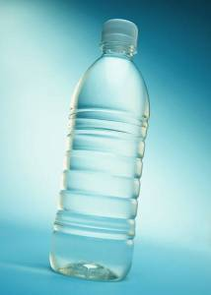
Eat Smart! By making a few small changes, you can lower your risk for diabetes. What foods you eat and how much you eat are very important for reducing your risk for diabetes. For example, try drinking water instead of soda. Or you can eat less by using smaller plates and bowls.

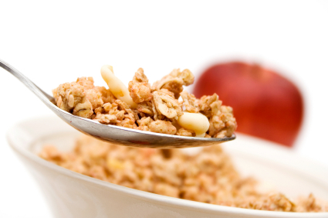
Eat Breakfast! Breakfast can help you have more energy. It can also make you feel better and think more clearly. Eating breakfast can also help reduce your reaction to stress and tiredness. Research has shown that people who do eat breakfast are less likely to be overweight. Start your day with a low- fat and whole grain breakfast. Try eating fruit, whole wheat or multi-grain breads, and low fat milk.


Eat your Colors! Eating fruits and vegetables at least 5 times a day can lower your risk of diabetes. Fruits and vegetables provide minerals and vitamins that your body needs and are good sources of natural fiber. Fiber lowers blood sugar, lowers cholesterol, and can help control your weight. Have a colorful variety of fruits and vegetables everyday at meals or for a snack.

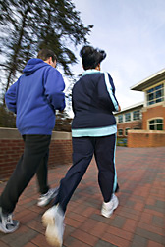
Get Active! Physical activity is the best thing you can do. It helps you burn calories and lose fat. Try to do at least 30 minutes of physical activity 5 to 7 days each week. Shorter periods several times a day such as 10 minutes, 3 times a day will work too. Walk, dance, work in the yard, or do any activity you enjoy. Just get moving!
What Are You Eating?
Using Your Food Diary

One way to reduce diabetes risk is to have a healthy body weight and eat healthy foods. Keeping track of what you eat is one of the most important ways to help you lose weight and eat healthy. Start today!

- For a week, write down in your food diary the type of food you eat, when you eat, and how much you eat.
- Write as much detail as you can. For example, if you have a sandwich for lunch: What type of meat was it? Did you have cheese on it? Mayonnaise? Lettuce? What type of bread?

This is a great way to start thinking about ways you want to make your current diet better. It will help you set up your personal program.

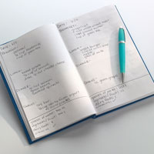
Bring the food diary to your Personal Planning Session to review with your health counselor.
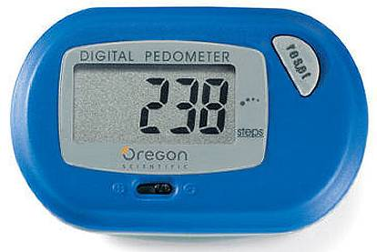
Pedometer Basics

What is a pedometer?
It is a little machine that counts the steps that you take when you walk.

How do I wear my pedometer?
- Wrap the leash around a belt loop.
- Clip the pedometer onto your waistband.
- Be sure it is lined up with one of your knees.
- At the end of the day, write down your steps on your calendar.
- Push the “reset” button to clear your pedometer.

Can my pedometer work on treadmills, stairs or bikes?
The pedometer will work anytime it can feel you taking a step. It cannot add the height of your steps like on stairs. But it counts every step you take whether you walk on a flat surface, uphill or downhill. It does not count steps when you are riding a bike.

A couple of other things:
- Walking 2,000 steps is the same as walking a mile. So walking 10,000 steps a day is the same as walking 5 miles.
- Do not get your pedometer wet! Do not wear it in the shower, tub, or pool.
What is an Action Plan?

Action plans are short term goals that you set for yourself that you can achieve to help you reduce your risk of diabetes.

Action plans should be:
- Something you want to achieve
- Realistic
- Specific
- Something you can achieve
- Written
- Revised every day


Ask yourself:
- What exactly am I going to do?
- How much am I going to do it?
- When will I do it?
- How many times a week will I do it?

Obtained from KAISER PERMANENTE
©2003, TPMG, Inc. All rights reserved
My Action Plan

To lower your blood sugar level, you need an action plan to reach your goal.
- Choose the area you want to work on first to prevent diabetes.
4 Ways I Can Prevent Diabetes
Get active  □ | Eat smart  □ | Eat breakfast  □ | Eat your colors  □

- Be specific about what you will do!
By the next phone call: (day) __________________ (time) ________
I will (write the plan here):

- Then ask yourself, "On a scale of 1 to 10, how confident am I that I can do this by the next phone call?" If you answer 6 or less, think about picking an easier goal to get you started.
On a scale of 1 to 10, I am ______confident that I can do this.
What could make this hard to do? ____________________________
___________________________________________________
What can I do to overcome these barriers? ______________________
___________________________________________________
Web Resources

To find more information about diabetes check out these websites.

American Diabetes Association

www.diabetes.org

Description: General information about diabetes. In addition, provides healthy recipes, weight loss and exercise tips. Information specific to minority ethnic groups is available in English and Spanish. User-friendly and informative.

Medline Plus by the National Institutes of Health
www.nlm.nih.gov/medlineplus/diabetes.html
Description: General information about diabetes. User-friendly and informative. Available in Spanish.

Plan Better Meals to Control
Blood Sugar

What is in Plan Better Meals to Control Blood Sugar?

Eat Smart.…………………………………………………………………………………………25
Eat Breakfast.…………………………………………………………………………………….26
Quick Breakfast Ideas………………………………………………………………….……..27
The Food Pyramid.………………………………………………………..…………………..28
Refined Grains…………………………………………………………………………………..29
Whole Grains…………………………………………………………………..………………..30
5 Ways to Eat Whole Grains.……………………………………………………………….31
Fiber…………………………………………………………………………………………………32
Eat Your Colors.…………………………………………………………………………………33
8 Ways to Add Fruits and Vegetables to Your Day……………….…………..……39
Proteins…………………………………………………………………………..………..………40
Fats………………………………………………………………………………..………..…...….41
10 Ways to Eat Less Fat………………………………………………….…………………..43
Drinking Water……………………………………………………………..…………………..44
Watch your Portions ………………………………………………………………….………45
Portions of Carbohydrates………………………………………………………………….46
Control your Portions.…………………………………………………..……………………47
Remember this Plate Every Time You Eat……….. …….…48
Weight Control and Portion Sizes………………………………………………………..49
Find the Balance ……………………………………………………………………………....50
Begin to Eat Smaller Portions.…………………………………………………………….51
Eat Smaller Portions at a Restaurant.…………………………………………………..52
Web Resources………………………………………………………………………..…….…..53
Eat Smart!
“Eating Smart” means eating a lot of different types of foods that have lots of vitamins, minerals, and fiber. It also means eating foods that are low in fat, sugar, and calories. Everyone in the family will benefit from healthy eating, so Eat Smart for the whole family. “Eating smart” means eating several of the following:
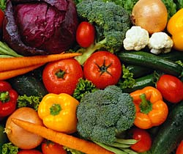



Vegetables Fruits Low-fat dairy products

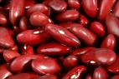
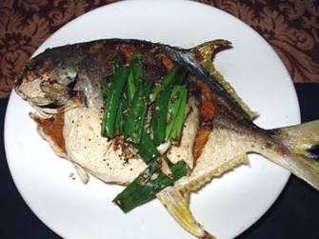
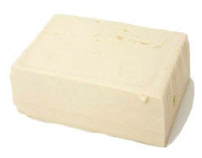

Beans Fish and lean meats Tofu

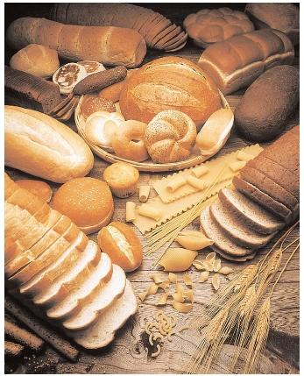

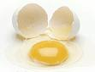
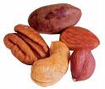

Eggs Nuts Whole grain products
Eat Breakfast!


- Breakfast is the most important meal of the day.
- In the morning you haven't eaten for about 10 hours and your energy is low.
- Even if you don't feel hungry, eat something in the morning. This will help you control your blood sugar.
- People who eat breakfast stay slimmer and are more mentally alert. They may even live longer than those who don't.
- You need to eat some protein at breakfast.
- Eating protein will give you more energy and help keep you from getting hungry later in the day.
- Try eggs or egg substitutes, plain or sugar-free yogurt, or cottage cheese.

Breakfast and Weight Control
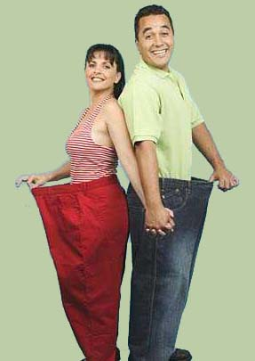
Eating a good breakfast may help you lose weight. Some people skip breakfast as a way to lose or control weight. People who skip breakfast tend to eat more throughout the day. Because of this, people who skip breakfast are more likely to be overweight.

Quick Breakfast Ideas
If You Feel Rushed Try These:

- Eat a sandwich or healthy pizza for breakfast. Breakfast doesn’t have to be a “traditional” breakfast food.

- Hard boiled eggs.

- Trail mix of nuts, dried fruits, pretzels, crackers, or dry cereal.


- Blend up a smoothie with nonfat yogurt or skim milk, bananas, berries, apples, oranges.

- Yogurt with fruit or nuts.

- Low-fat cottage cheese topped with fruit.

- Add dried fruit or nuts to hot cereal such as oatmeal or cream of wheat.

- Single serving of whole-grain cold cereal with skim milk.
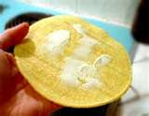
- One or two tortillas with low-fat cheese.

- Whole-grain toast, bagel, or English muffin with cheese.

- Peanut butter or hummus on whole-wheat toast.

By eating something in the morning, you will see how much better you feel during the day!
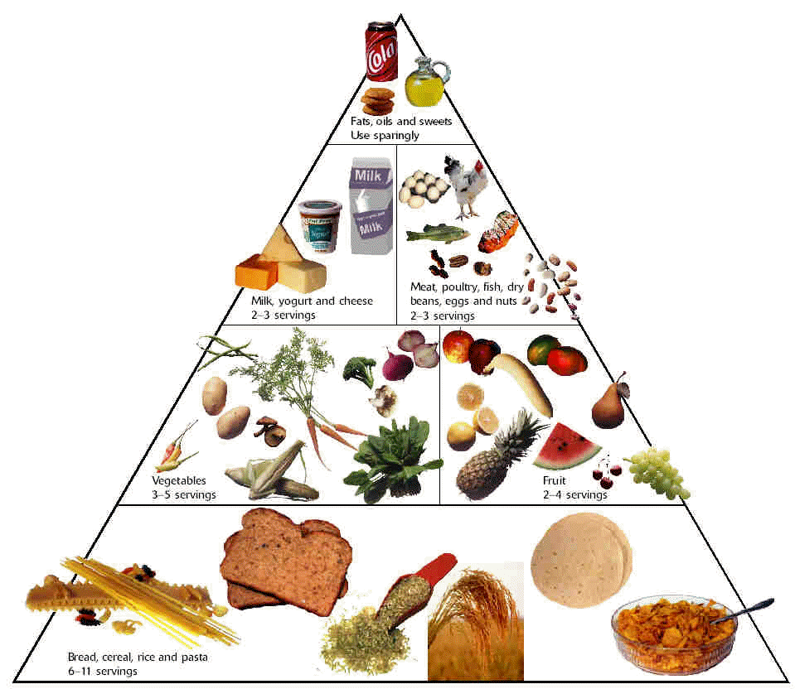
The Food Pyramid
Vegetables 3 – 5 servings
Fruits 2 – 4 servings
Meat, poultry, fish, dry beans, eggs, and nuts 2 – 3 servings
Milk, yogurt, and cheese
2 – 3 servings
Fats, oils, and sweets Use sparingly
Combining proper food groups and regular exercise will help you maintain your blood sugar.

This Food Guide Pyramid divides food into six groups, which vary in size to show relative amounts of servings for each group. This pyramid differs from the Food Guide Pyramid released by the USDA. Image obtained from http://www.lasalad.com/consumers.html.
Bread, cereal, rice, and pasta
6 – 11 servings
Refined Grains
- Processed grains are also called refined grains. This means that they have gone through a process that removes the outer layers of the grain seed.
- Refined grains are lighter in color and finer in texture than whole grains.
- Refined grains have less fiber, less iron and fewer vitamins than whole grains.
- Eat less refined grains and more whole grains to prevent diabetes.

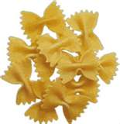
- Examples of refined grains are:
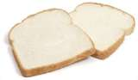




Cereal Noodles White bread

White Rice Sweet bread Croissant
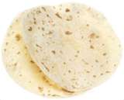

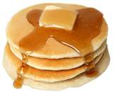

Pancakes Flour tortilla Cookies

Which of these can you eat less often? Circle the one you would like to replace with a whole grain version.
Whole Grains

- A whole grain means that the entire grain seed or kernel is used.
- A whole grain is often darker in color than refined grains.
- Whole grains have more vitamins, minerals and fiber.
- Fiber in whole grains helps prevent diabetes, heart disease, and high blood pressure.
- Look for “whole grain” or “whole wheat” products.
- At least half of the grains you eat should be whole grains.

Circle the ones you will like to try:
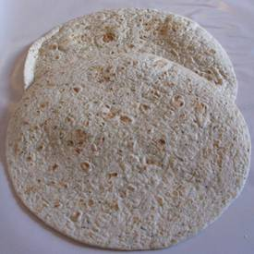
 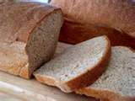 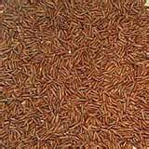 Whole-wheat noodles Whole-wheat bread Brown rice

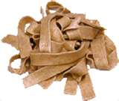
 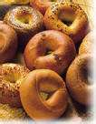 Whole-wheat tortillas Oatmeal Whole-wheat bagels
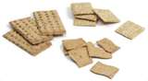

Whole-wheat crackers Popcorn Whole-wheat spaghetti
5 Ways to Eat Whole Grains


1. Start your day with a bowl of oatmeal or whole grain
cereal. You can use these cereals in place of grits or
refined cereals like Corn Flakes.


2. Use whole-wheat flour for all or part of the white
flour in baking recipes.


3. Try brown rice or whole-wheat pasta with dinner.

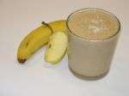
4. Add oatmeal to your yogurt or smoothie.

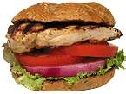

5. Make your favorite sandwich with whole-wheat
bread.

Fiber
- Fiber is a type of carbohydrate. Fiber comes from plant foods, so there is no fiber in animal products.
- Fiber helps control blood sugar because when you eat it slows down the absorption of carbohydrates.
- The pictures below are excellent sources of fiber because they contain 5 grams or more of fiber per serving.

Circle one of the following high fiber foods you will eat this week:

Bran cereal
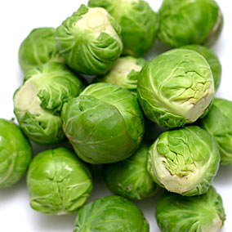
1/2 cup (9 grams of fiber)


Brussels sprouts Artichoke, cooked
1 cup (6.4 grams of fiber) 1 medium (6.5 grams of fiber)


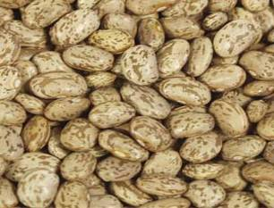

Pinto beans Lentils Black beans
½ cup ½ cup ½ cup
(7.5 grams of fiber) (8 grams of fiber) (8 grams of fiber)
Source: Mayo Clinic http://www.mayoclinic.com/health/high-fiber-foods/NU00582
Eat Your Colors!
The Benefits of Eating Fruits and Vegetables
Fruits and vegetables may help to prevent diabetes and maintain a healthy weight. They have lots of fiber that can reduce your risk of getting diabetes.
- Eating fruits and vegetables at every meal will give you a variety of vitamins, minerals, and fiber that your body needs to stay healthy.
- There are a wide variety of colors in fruits and vegetables, so mix them up during the day and at mealtime.
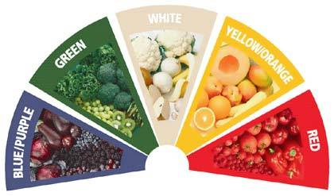
- Eat 5 or more fruits and vegetables everyday.
- The deeper the color, the more benefits you get because they usually have more vitamins and minerals.
From www.5aday.org (5 A Day The Color Way)
Blue / Purple Fruits and Vegetables
Foods in this group will help with your memory function better, help you age in better health, and maintain a healthy urinary tract. Eat fruits and vegetables like these:

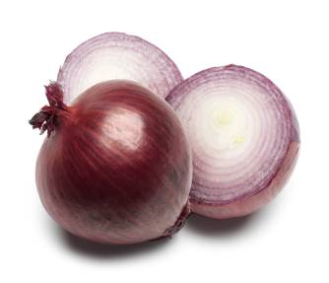



Eggplant Purple onions Plum
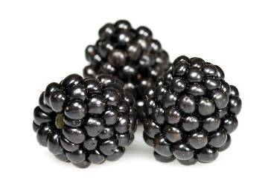

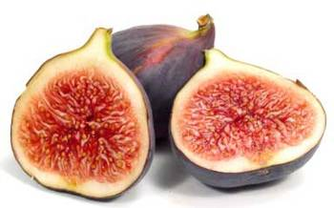

Figs Purple grapes Black berries




Purple cabbage Purple sweet potato Blue berries
Green Fruits and Vegetables


These fruits and vegetables are important for your eyesight, and for keeping your bones and teeth strong. Include these fruits and vegetables in your meals:


Turnip greens Leeks Spinach Kale


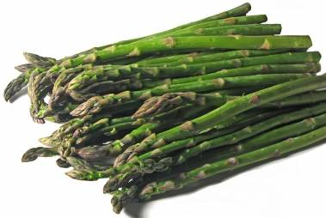

Asparagus Broccoli Zucchini
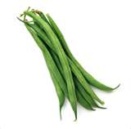

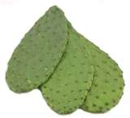

Cactus Green bell pepper String beans

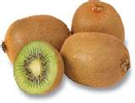


Cherimoya Honey dew melon Kiwi
White Fruits and Vegetables
Eating fruits and vegetables that are white, tan or brown in color keeps your heart healthy. They also help keep healthy levels of cholesterol.

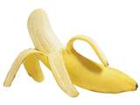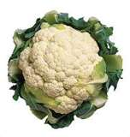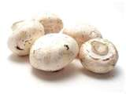
Banana Cauliflower Mushrooms

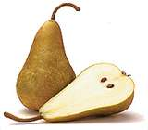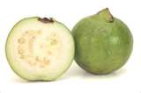
Pears Guava White peach

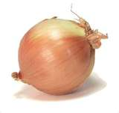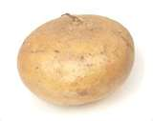
Garlic Yellow onion Jicama
Yellow / Orange Fruits and Vegetables
These brightly colored foods are beneficial for eyesight, heart health. They also keep your immune system functioning at its best.




Yellow bell peppers Yellow zucchini Oranges


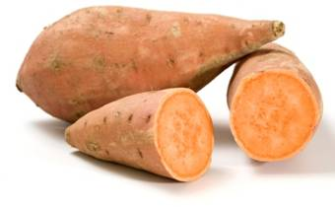


Yams Apricots Corn

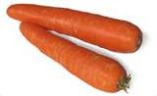

Peaches Carrots Nectarines

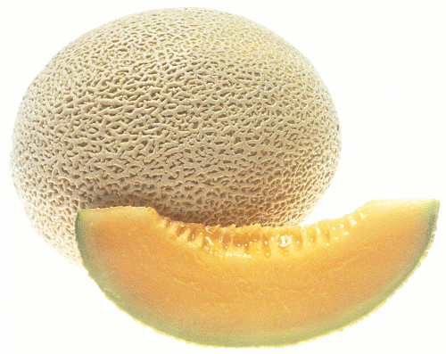
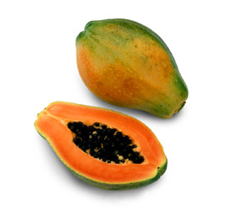

Cantaloupe Mangos Papaya
Red Fruits and Vegetables
Red fruits and vegetables keep your heart, memory, and urinary tract working at their best.

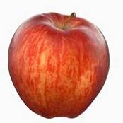
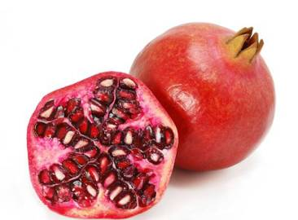

Cherries Pomegranates Apple


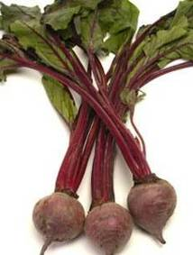

Radishes Red bell pepper Beets
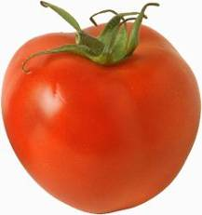

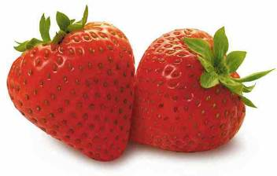

Strawberry Tomato Raspberries
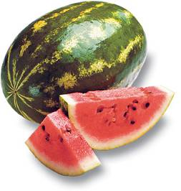

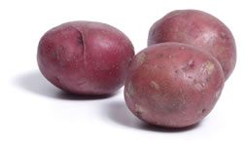

Watermelon Guava Red potato
8 Ways to Add
Fruits and Vegetables to Your Day

Circle the ones you would like to try this week.

- Keep a bowl of fresh fruit out.

- Keep raw, cut up veggies in the refrigerator.

- Create your own fruit smoothies.

- Buy frozen vegetables that can be cooked quickly in a microwave.

- Add chopped vegetables to your favorite pasta sauce.

- Add sliced fruit to your favorite breakfast cereal.

- Make a fruit salad from your favorite fruits.

- Add spinach to your salad every night with dinner, and top with dried raisins or cranberries.

Proteins
Protein foods are important because they help build bones, muscles, skin and blood. When eating protein, choose lean or low fat foods. Examples of foods that contain protein are:



Eggs Different types of beans Skinless chicken

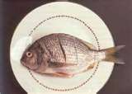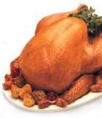

Fish Turkey Salmon

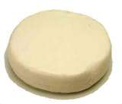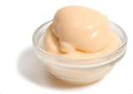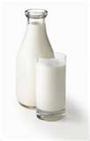
Low fat beef and pork Low fat cheese and milk products
Fats

Eating lots of fats increases your risk of developing diabetes, heart disease, and certain types of cancer. There are different types of fats in the foods we eat:

Unsaturated Fats – are “good” fats. They are also known as mono or polyunsaturated fats. These fats actually increase your use of insulin and are recommended. Their benefits include better blood control by signaling to your brain that you are satisfied after a meal. However, unsaturated fats should be eaten in small amounts, as too much is unhealthy. Examples of foods that have unsaturated fats are olive oil, avocados, nuts and fish.


Saturated Fats and Trans Fats – are “bad” fats. They raise the level of cholesterol in your blood and block arteries. This increases your chance of heart disease and high blood pressure. Examples of saturated fats are margarine, lard, and meat fats.
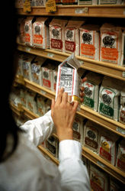

Start reading food labels for the fat content today!
How can you tell if a fat is saturated or unsaturated?

An easy way to tell if a fat is saturated or unsaturated is to leave it out at room temperature.


- The more unsaturated a fat, the more liquid it is at room temperature. Olive oil is liquid which means it has unsaturated fats.

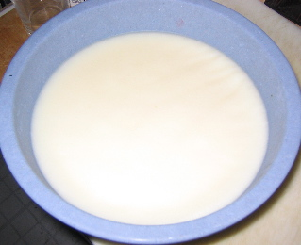
- The more saturated a fat, the longer it will take to melt at room temperature. For example, lard takes a long time to melt, which means that it has saturated fats.

What kind of oil are you using?
10 Ways to Eat Less Fat

Circle the options you would like to try this week.

1. Remove the fat from meat and skin from chicken.

- Buy meats that are at least 90% lean or are lean cuts or
boneless, skinless chicken breasts and turkey cutlets.

- Instead of frying, try broiling, grilling, roasting, baking, or poaching your meats.

- Use olive oil, canola, grape seed oil or a light oil spray when cooking instead of butter, shortening or lard.

- Choose low-fat or non-fat dairy products such as milk, yogurt and cheese.

6. Look for “round” or “loin” when shopping for lean beef, or “loin” or “leg”
when shopping for lean pork or lamb.

7. Choose lean or low-fat luncheon meats for sandwiches.


8. Choose to have fish for lunch or dinner.

9. Instead of using meat, make dishes with kidney
beans, pinto beans or lentils or nuts.

10. Use turkey meat to season your beans instead of
fatty meats like salt pork or smoked ham hocks.
Drinking Water

Water is the best way to break down blood sugar levels.

Drinking water will also:

- Improve your energy

- Help you concentrate

- Help you feel better when you are physically active

- Remove poisons and waste products from your body

- Keep your skin healthy and glowing

- Help you lose weight

- Reduce headaches and dizziness

- Help you digest your food better

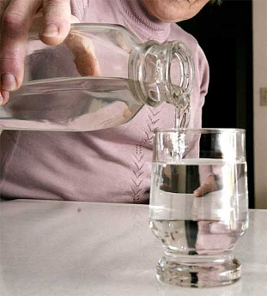
You should drink at least 8 to 10 cups of water everyday even if you do not feel thirsty.

One way to tell if you are drinking enough water is the color of your urine (pee). It should be very light or clear. If it is dark yellow, you are not drinking enough water.

Drinking soda, sports drinks, and coffee will not help your body stay healthy. Many people think sports drinks are healthy, but they have carbohydrates that increase blood sugar. Water is best!
Watch your Portions
- A portion is how much food we eat at one time, either for a meal or a snack.
- The amount of food you eat may be more or less than the serving size or portion recommended by the Food Pyramid.
- Research shows that people eat less if they eat smaller portions, which can help in weight loss or weight control.
- Compare the amount of food you eat to the recommended serving sizes on the food pyramid.
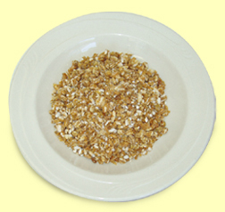
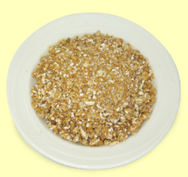
Correct portion Too much

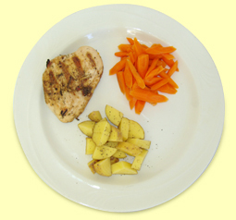


Photographs obtained from: http://www.stayfiteatright.org/root/eat_right/eat_right3.html

Portions of Carbohydrates
One way to control your blood sugar is to control the portion size of foods that are high in carbohydrates. Here is a list of foods that have carbohydrates. Use this list to find out what a portion is equal to.
Bread and Grains | Fruits and Vegetables | Milk
Cooked rice = 1/3 cup | Green beans= 1/2 cup | Fat free milk= 1 cup
Oatmeal = 1/2 cup | Corn= 1/2 cup | Fat free evaporated milk = 1/2 cup
Cooked cereal = 1/2 cup | Mashed potatoes = 1/2 cup | Fat free plain yogurt = ¾ cup
Bread roll = half | Potato= 1 small
Bagel = read food label | French fries = 10 - 12 | Low fat milk 1% = 1 cup
Dry cereal = read label | Yams= 1/2 cup
Animal crackers = 8 | Fruit cocktail = 1/2 cup | Reduced fat milk 2%= 1 cup
Graham crackers = 3 | Watermelon = 1 ¼ cup
Saltine crackers = 6 | Strawberry = 1 ¼ cup | Whole milk: 1 cup
Popcorn= 3 cups | Peach= 1
Bread = 1 slice | Guava = 1
Hamburger buns = half | Kiwi= 1
Pancakes = 2 | Mandarins= 2
Pasta = 1/2 cup | Mango= half
Tortilla = 1 | Apple= 1
Beans = 1/2 cup | Pineapple = ¾ cup
Lentils = 1/2 cup | Orange = 1
 | Nectarine = 1
 | Papaya = 1 cup
 | Large Pear = half
 | Cantaloupe= 1 cup
 | Small banana = 1
 | Apricots= 4
 | Grapefruit= half
 | Small grapes= 17
 | Plantain= 1/2 cup
 | Cherimoya = 1/2 cup
 | Cherries = 12
 | Plums= 2
 | Coconut juice= 1 ½ cup
 | Grape juice = 1/3 cup
 | Apple juice = 1/2 cup
 | Orange juice = 1/2 cup
How many servings of carbohydrates did you have today?
Write it here________________________________
Obtained from Nuestro Canto de Salud, Diabetes Project, San Mateo County
Control your Portions

When you sit down for a meal, draw an imaginary line through the center of your plate. Draw another line to divide one section into two. Use a 9 inch plate

Fill one small section with carbohydrates. Carbohydrates include grains like pasta and bread. Carbohydrates are also starchy vegetables like corn or potatoes.

Fill another small section with protein – foods like lean meat, fish, poultry, beans, nuts, cheese, or tofu.

Fill half of your plate with non-starchy vegetables like broccoli, salad, carrots, tomatoes, cauliflower, mustard greens and collard greens.

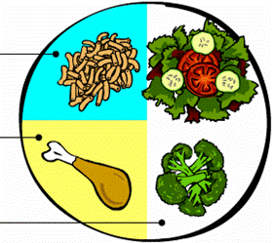
Remember this PLATE Every Time You Eat
Carbohydrates like grains or
starchy foods
Protein
1
2
3
4
5
6
7
8
9
Your plate should be no bigger than 9 inches
Non-starchy Vegetables
Weight Control and Portion Sizes

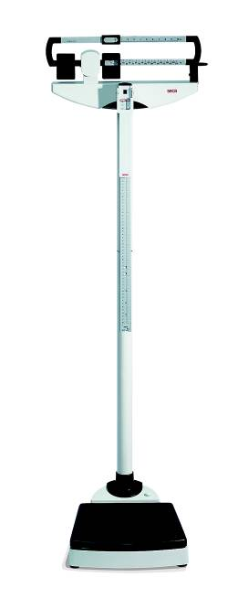
Why should we watch our portions?

- If we eat smaller portions we will be eating fewer calories.

- Eating fewer calories will help us lose weight.

- Eating smaller portions make it easier for our body to control our blood sugar and prevent diabetes.

How are weight control and diabetes related?
- Being overweight increases your chance of getting diabetes.
- When you are over weight, it is harder for your body to lower your blood sugar.
- You can lower the risk of getting diabetes by losing even a little bit of weight.
Find the Balance

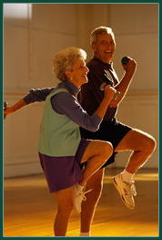
- Your weight is a balance of the number of calories you eat and the amount of energy you use being active.
- If you get more calories from food than you spend in activity, you will gain weight. You have eaten more calories than your body can use.
- The good news is that the opposite is also true. If you use more calories being active than the calories you eat, you will lose weight.
- The best way to keep in balance is to eat less and be more active.

What physical activity did you do today to balance the number calories you ate today?
Write it down here_________________________________

Begin to Eat Smaller Portions

Here are some tips for eating smaller portions:

• Drink two glasses of water before you eat
your meals.

• Use smaller plates, bowls and glasses when
you eat or drink.

• Eat slowly. It takes your body at least 20 minutes to realize it’s full.

• Put snacks on a plate and put the bag away. Eating directly from the
package leads to overeating.

• Wait a few minutes before getting a second helping. You may find you’re
no longer hungry.

• Start each meal with a salad.

Eat Smaller Portions at a Restaurant

Circle the one you would like to try next time you are at a restaurant.

Here are some tips for eating smaller portions:


- At a restaurant share a meal with a friend

- Order an appetizer instead of a full meal

- Instead of French fries order a salad

- As soon as your meal is served, ask for a box so you can take half of it
home

- Order a small hamburger instead of a large one

- Pass on the tortilla chips

- Ask the waiter not to bring the bread

Web Resources
To find more information about nutrition check out these websites.
Aim for Healthy Weight by the National Heart Lung and Blood Institute
www.nhlbi.nih.gov/health/public/heart/obesity/lose_wt/index.htm

Description: Provides a menu planner, portion sizes, and healthy food exchanged for those high in fat.

Serving size card by the National Heart Lung and Blood Institute
hp2010.nhlbihin.net/portion/servingcard7.pdf

Description: Provides recognizable everyday objects to determine serving size.

United States Department of Agriculture
fnic.nal.usda.gov/nal_display/index.php?tax_level=1&info_center=4

Description: Provides information on eating better, dietary supplements, vegetarian nutrition, recipes, and meal planning, the food pyramid

State of Ohio Commission Minority Health
mih.ohio.gov/cooks.stm

Description: Recipes for healthier versions of African-American, Asian, and Hispanic/Latino foods.

Consumer Nutrition Hotline provided by the American Dietetic Association
Phone: (800) 366-1655
Description: Listen to food and nutrition messages recorded by a registered dietitian in English or Spanish from 8:00 AM to 8:00 PM Central Time, Monday through Friday.

Food Labels
and
Diabetes Prevention
What is in Food Labels
and Diabetes Prevention?

Reading Food Labels.………………..……………………………………………………….56
Keeping these Numbers in Mind.…………………………..………………………......59
Read Food Labels in 5 Easy Steps……………………….….…………………..………60
Web Resources……………………………………………………..…………………..………61
Reading Food Labels
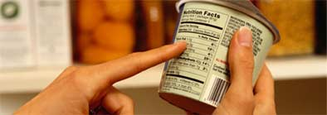

Learning to read food labels on packaged foods may help you learn how to make healthy food choices.
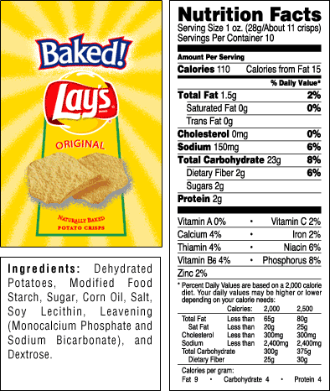
Here is a potato chips label. We will break it down from top to bottom to help you learn how to read food labels.

Serving Size
This number tells you how much there is in a portion. The information on the label is for the serving listed.

Calories
Calories are a measure of the amount of energy a food gives your body. This energy is used to perform everything from basic functions such as breathing to complex tasks like dancing.

Total Fat
This number tells you how much total fat there is in a portion. Saturated fat should be kept to a minimum. Trans fat is the worst of the fats and should be avoided as much as possible. Trans fat is listed in ingredients as “partially hydrogenated” oils.

Sodium
Sodium means salt. Eating too much salt makes your blood pressure go up.

Total Carbohydrate
This number includes fiber and sugars. By controlling carbohydrate portions you will be controlling your blood sugar because carbohydrates are changed into blood sugars in our body. If you only look at the sugar number, you might exclude nutritious foods such as fruits and milk thinking they are too high in sugar. You might also over eat foods such as cereals and grains that have no natural or added sugar, but do contain a lot of carbohydrate.

Dietary Fiber
Fiber is a type of carbohydrate that our bodies can’t break down. This is the reason why it does not raise blood sugars. Choose foods that are high in fiber.
Keeping these Numbers in Mind
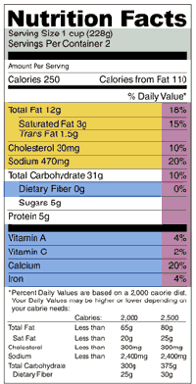
Keep these numbers in mind when you go
shopping and choose the ones that best go with
your goals. You do not need to find foods that
have all these recommended numbers.

Fat free = less than 0.5 g of fat or saturated fat
per serving
Low fat = less than 3 g of total fat

Sodium free = less than 5 mg of sodium per
serving
Low sodium = 140 mg of or less per serving

Total carbohydrate = a serving size is 15 g or
less
Sugar free = less than 0.5 g of sugar per serving

Excellent source of fiber = 5 g or more of fiber
per serving
Good source of fiber= 2.5 to 4.9 g of fiber per
serving


Cut out and take it with you when you go shopping
- - - - - - - - - - - - - - - - - - - - - - - - - - - - - - - - - - - - - - - - - - - - - -
Keep these numbers in mind when you go shopping. You do not need to find foods that have all these recommended numbers.

Fat free = less than 0.5 g of fat or saturated fat per serving
Low fat = less than 3 g of total fat

Sodium free = less than 5 mg of sodium per serving
Low sodium = 140 mg of or less per serving

Total carbohydrate = a serving size is 15 g or less
Sugar free = less than 0.5 g of sugar per serving

Excellent source of fiber = 5 g or more of fiber per serving
Good source of fiber= 2.5 to 4.9 g of fiber per serving
Read Food Labels in 5 Easy Steps

- Start with the serving size

- Check the calories

- Limit fats and sodium.

- Limit total carbohydrate. Choose foods that have 15 grams or less per serving if you want to prevent diabetes.

- Choose foods high in dietary fiber.

Web Resources

To find more information about food labels check out these websites.

U.S. Food and Drug Administration
http://www.cfsan.fda.gov/label.html
Description: Provides an overview on food labels.

“Test Your Food Label Knowledge” (FDA)
www.cfsan.fda.gov/~dms/flquiz1.html
Description: Provides a test on your food label knowledge.

Get Active!
What is in Get Active?

Get Active…………..…………………………………………………………………...………..64
Move More, Sit Less.…………..………………………………………………………….....65
What’s Your Excuse for Not Being Active….……………………………………..…..67
Getting Started.……………………………………………………………………..………….70
Why is Walking so Great?.……………………………………………………………..…..72
10 Ways to Walk More. .……..73
How You Respond to Physical Activity………………………………….…………..…74
Stretch those Muscles……………………..………………………………………….……...76
Safe and Easy Stretches.………….. …….…77
10 Ways to Stay Active.. .……..80
Web Resources……………………………………………………………………..…………..81
Get Active!

People who are more active are less likely to get diabetes. Regular physical activity like walking can:
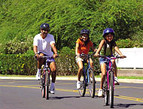
- Improve how your body uses and breaks down blood sugar
- Burn off extra calories to help you maintain a healthy weight
- Help control high blood pressure

Other good things you get from physical activity:
- Lower risk for stroke, heart disease, or colon or breast cancer

- More energy and better mood
- Better sleep
- It’s fun
- Feel better about yourself
- Set an example for your family or friends
- Can be time to spend by yourself or with friends or family

Exercise does not need to be vigorous to give us health benefits
Move More, Sit Less

Moving more does not mean going to a gym or an exercise class. Physical activity is any body movement that burns energy or calories. There are two types of physical activity, moderate and vigorous.
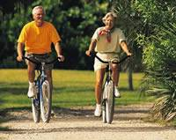
Moderate activity is when your lungs are working too hard to sing, but you can carry on a conversation while exercising. Here are examples of moderate activities and exercises.
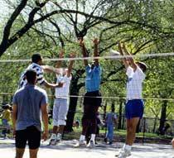


Bicycling Mowing the lawn Volleyball

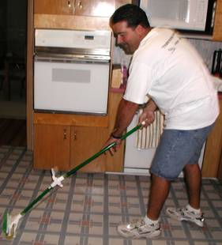
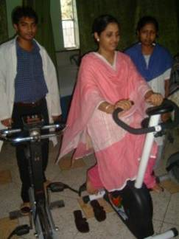

Raking leaves Cycling on a stationary cycle Mopping floor
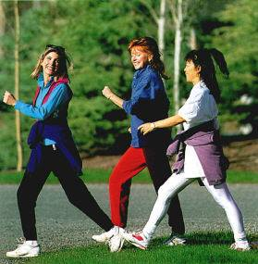

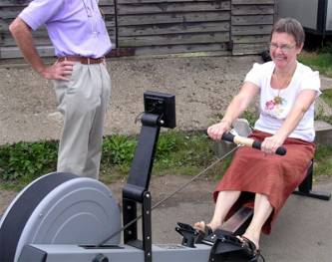
Walking briskly Rowing Dancing
Vigorous activity: is when you cannot say more than a few words at a time. Some examples of vigorous activities and exercises are:

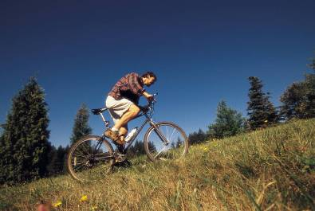
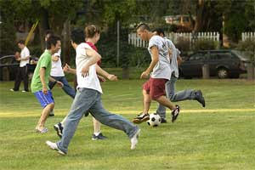

Playing soccer Swimming laps Brisk bicycling up hills



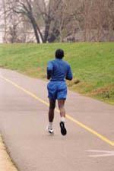

Tennis (singles) Playing basketball Hiking Running

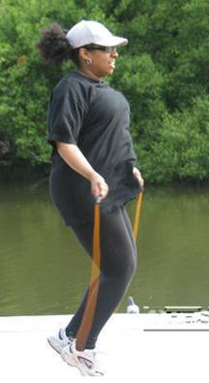

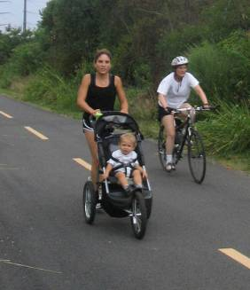
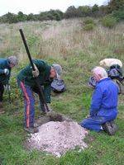


Jumping rope Jogging Digging holes Climbing stairs
or hills
What’s Your Excuse for
Not Being Active?

- If you are not active, it is likely that you have reasons why. Perhaps you have never been very active.
- Think about what is keeping you from being active and write it down here: _________________________
- Now think about ways to overcome your barriers. Write your ideas here: ____________________________________
_______________________________________________
- You can also try one of the following suggestions:

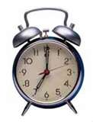
Not enough time? Few people have time to exercise. The important thing to remember is make time for something you like to do. For example, try shorter periods of activity spread throughout the day, such as three 10-minute walks. This way you will not feel you do not have 30 minutes to exercise.


Too expensive? Remember you do not need to go to a gym to exercise. Choose low-cost options, such as walking.

Bad weather? Too hot, too cold, too wet, too windy - make plans to exercise no matter what the weather’s like. Get clothes that helps you be comfortable in all weather. Try walking in the rain or exercising to a videotape.


Too tired? It is often a lack of exercise that makes you tired. Exercise actually helps give you more energy. Try it!

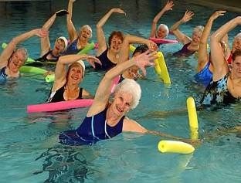
Too shy? People often are shy, especially at first. People sometimes feel uncomfortable with their bodies. But be proud that you are taking care of your body by getting active.

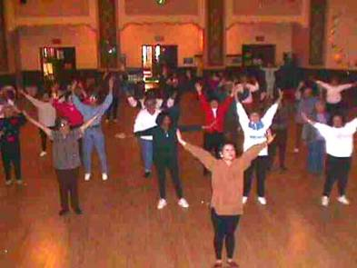
Not safe? Some people feel it is not safe to walk in their neighborhood. Try finding an indoor activity such as an exercise class at a community center.
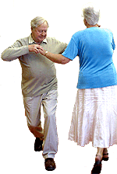
It’s boring? Find something you enjoy doing. Try different activities on different days. For example, listen to music while you exercise.


It hurts? If certain exercises hurt some parts of your body, find other exercises that will not hurt. For example, if walking hurts your knees, try chair exercises or swimming instead.

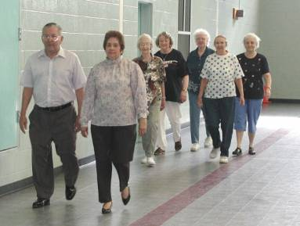
Want Company? Exercise is a great way to spend time with people you care about. Spend time catching up with a neighbor or relative during a walk around the block. Take an exercise class with a friend at your local community center. Having a partner is a great way to help you stay motivated.

Getting Started

Should I go see a doctor before I start exercising?
Most people don’t need to see a doctor before they start a physical activity,
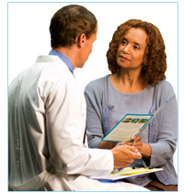
but you should first check with your doctor if you:
- have heart trouble or have had a heart attack
- are over 40 and are not used to doing physical activity
- have a family history of heart disease at an early age
- have any other serious health problem

How do I get started?
Remember any activity will make you healthier, but start at the level that fits you best.
- If you have not exercised for years, start slowly and then build up. You might want to try yard work, cooking, or pushing a wheelchair.

- The next level would be light activity. These might include slow walking, childcare, or table tennis.
- The next level would be moderate activity. Try walking briskly, dancing, or weeding a garden.
- High activity would include walking briskly uphill, soccer, or heavy digging.

Most importantly find the level that fits you best
and choose an activity you will enjoy.

How often and how long should I exercise?
- Harder is not better, but longer is.
- Your exercise goal is to improve from wherever you are right now!
- Work your way up so you do exercise 5 days per week for 30 minutes.
- The ideal is to exercise at least 5 days per week for 30 minutes.

Be safe. Follow these simple tips:
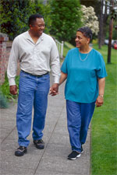
- Trying to improve is good. However, overdoing it can be dangerous. Do what feels comfortable.
- Try to exercise with a buddy or in a place with other people.
- Avoid dark and deserted places.
- If you use headphones while exercising, make sure you can hear what is going on around you.
- Drink water before, during and after exercising. If you feel thirsty, then you are probably dehydrated.
Why is Walking so Great?


- Almost everyone can do it.
- You can do it anywhere.
- You can do it anytime.
- It doesn’t cost anything.
- It is fun and reduces stress.

How fast should I walk?
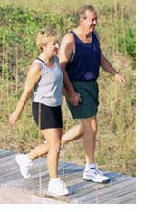
- Work up to a fast walk.
- You should be able to feel your breathing, feel your heart beating, and feel warmer.
- You should be able to chat while walking. If you cannot, then you are going too fast.
- If you feel like you could sing a song loudly while walking, try walking a little faster or further.
- You may or may not sweat.
10 Ways to Walk More

1. Walk with your children or grandchildren.

2. Plan a regular walk for each morning.

3. Take the stairs instead of the elevator.

4. If taking the bus or driving, get off 1 or 2 stops early.
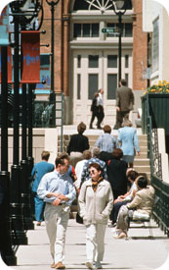
5. If you can, walk while doing errands. Wear comfortable
shoes.

6. Bring spare shoes and clothes to work.
○ At work, use part of your lunch break to take a walk.
○ Have a co-worker join you.

7. Check to see if there is a walking group in your area. If not, start your
own!

8. Park your car a few blocks away, and walk the rest of the way.
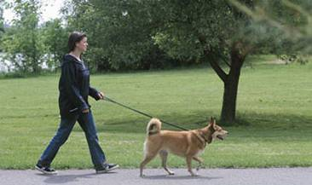
9. Walk your dog, or walk with a friend who walks a
dog.

10. Walk around during TV commercials or while talking on the phone.
How You Respond to Physical Activity

These are normal responses to exercise:

- Increase in heart rate and breathing, breathing deeper.
- Increase in blood pressure.
- Sweating if you work out long enough.
- Feeling flushed.
- Feeling a little tired.
- It is normal to be a little stiff or sore for 1-2 days.

These mean slow down:

- Can’t carry on a conversation while exercising.
- Still short of breath 10 minutes after stopping.
- Stiff or sore muscles for several days after exercise.
- You shouldn’t be so tired that you need to sit or lie down for a couple of hours.
- Nausea during or shortly after exercise.

These mean stop and see your doctor in the next couple of weeks:

- Difficulty breathing.
- Feeling dizzy or lightheaded.
- Feeling confused, or having cold sweats.
- Severe muscle, joint or bone pain.
- Swelling that lasts for more than a day after exercise.

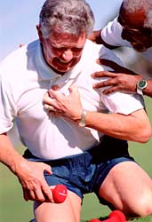
Call 911 for any of these during or after exercise:
- Chest pain, tightness or heaviness.
- A crushing feeling from chest up to jaw and/or neck or down your left arm.
- Severe shortness of breath.
- Your heart is beating too fast, too slow, or skips for more than 10 minutes.
Stretch those Muscles

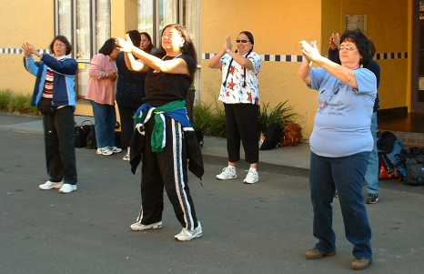
Stretch before any activity. You can do this with specific stretches, like the ones we mention on the next pages. If you prefer, instead of stretching you can warm up by doing your activity slowly for the first few minutes. But stretching is one of the best ways to prevent muscle soreness, cramps, and injuries. Stretching also helps you be more flexible and feel relaxed.

A Few Points about Stretching:
- Move slowly until you feel the muscle stretch.

- A safe stretch is gentle and relaxing.


- Hold the stretch steady for 15 to 30 seconds. Do not bounce.

- Stretch within your own limits. Don’t compete.

- Do not hold your breath.

Safe and Easy Stretches

Neck Rolls
- Drop your head straight forward toward the floor.
- Let it hang for a moment and keep your back upright.

- Then very slowly tilt your head to the right over your shoulder as shown.
- Bring your head upright.
- Do not let your head roll back.
- Slowly tilt your head to the left over your shoulder.
- Repeat 3 times.

Shoulder Rolls
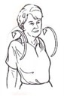
- Lift your shoulders up toward your ears.
- Then slowly roll your shoulders in a big circle moving them back, around, forward and up.
- Repeat 3 times slowly.
- Repeat for the opposite direction.

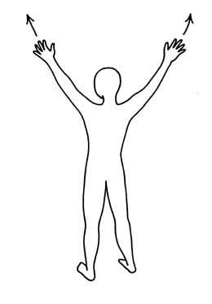
Arm Reaches
- Stand up straight with your feet shoulder-width apart.
- Counting to 5, stretch both your arms to the ceiling. Keep your feet flat on the floor.
- Do this 10 times.
- When finished, shake out your arms.
Arm Circles
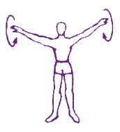
- Hold your arms straight out from the shoulders with your fingers spread and palms down.
- Rotate your arms in circles 10 times forward and then 10 times backward.
- When finished, shake out your arms.
- Over time work up to 20 circles in each direction.

Waist Bends
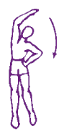
- Stand up tall with your feet shoulder-width apart.
- With one arm extended up over your head and the other on the hip, slowly bend your body sideways.
- Look straight ahead and count to 10. Slowly return to the straight-up position.
- Repeat by bending the other side of your body.
- Over time work up to 5 of these.

Heel Stretch
- Stand facing a wall an arm’s distance away.
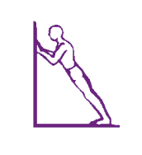
- Place your knees straight and your heels flat on the floor.
- With your hands resting on the wall, allow your body to lean forward by bending your elbows slowly.
- Keep your legs and body straight and your heels on the floor.
- Hold for 10-20 seconds.
Calf Stretch
- Stand straight with feet shoulder-width apart.
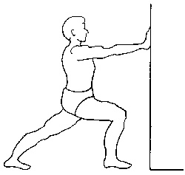
- Step forward with your right foot, slightly bending your right knee. The front of your knee should be lined up with the front of your toes.
- Try to keep your left leg straight and your left heel should remain on the floor.
- Hold for 10-20 seconds.
- Slightly bend your left knee. Hold for 10-20 seconds.
- Repeat for the opposite side.

Back Press
- Lie on your back with your knees bent and you hands behind your neck.
- Keep your feet flat on the floor.
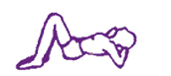
- Take a deep breath and relax.
- Press the small of your back against the floor.
- Tighten your stomach and buttock muscles.
- Hold for 5 seconds. Relax.

Back Stretch
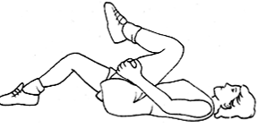
- Lie on your back with your knees bent.
- Place your arms flat on the floor at your sides.
- Keep your feet flat on the floor.
- Take a deep breath and relax.
- Hold on to the back of one knee (not the top of the knee) with both hands and pull as close to your chest as possible.
- Return to the starting position.
- Repeat with the other leg.
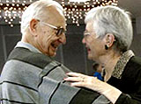
10 Ways to Stay Active
- Make exercise as enjoyable as possible. You want exercise to enhance your life, not control it.

- Set up regular, specific times to exercise. Make it a commitment not just a promise.


- Have back-up plans for weather changes, travel, holidays, and emergencies.

- Make appointments with friends to exercise.

- Set realistic, appropriate goals. Small steps build success.

- Check your self-talk. Talk to yourself as you would a good friend.


- Reward yourself. Do something that you normally wouldn’t do for yourself.

- Establish helping relationships. Be specific when you ask for support.

- Change your self image to a person who is active. Imagine yourself as being where you want to be.

10. Remember what it is you really want from your exercise. Focus on this
vision rather than any immediate resistance to exercising.

Obtained from “The Physical Activity Book: A guide to getting more active” from Stanford Center for Research in Disease Prevention
Web Resources
To find more information about physical activity check out these websites.

My Pyramid—U.S. Department of Agriculture (USDA)
www.mypyramid.gov/pyramid/physical_activity_tips.html

Description: Provides suggestions for getting exercise at home, at the office, and at play.

National Institute and Digestive and Kidney Diseases
win.niddk.nih.gov/publications/active.htm

Description: Provides you with information on physical activity. Includes a suggested activity journal for beginners.

American Association of Retired Persons (AARP)
www.aarp.org/health/fitness/

Description: Provides physical activity information and suggestions for adults over 50.

The Walking Site
www.thewalkingsite.com/howtowalk.html

Description: For walkers at all levels: beginners, marathon walking, walking fast, race walking, and more. Includes message board for virtual interaction with other walkers.

Stress
and
Diabetes

What is in Stress and Diabetes?

Stress…….…………..…………………………………………………..…………………….…..84
Ways to Stay Calm….…………..……………………………………………..…………......85
Healthy Stress……………………………………….…………………………………………..87
Web Resources……………………………………………………………………..…………..89

Stress


- Stress results when something causes your body to behave as if it was feeling a threat.

- Sources of stress can be physical, like injury or illness. Or they can be mental, like problems in your family, job, health, or finances.

- Stress can change blood sugar levels. It does this in two ways:

  - People under stress may not take good care of themselves. They may drink more alcohol, exercise less or may forget to plan good meals.

  - Stress hormones may also change blood sugar levels directly by keeping your body from producing insulin or using it properly.

People at risk for diabetes should take time out to relax and keep their stress levels under control.
Ways to Stay Calm
Even though we cannot always control or change our lives, we can learn to control or change how we respond to stressful events. Getting physically active and stretching your body are some ways to relax and stay calm. Here are other ways to help you relax:


Get enough sleep
Sometimes you feel stressed because your body is saying you need to rest. When you are well rested, you will feel more alert without relying on caffeinated beverages and sugary foods to get you through the day. A lack of sleep makes it harder for your body to control blood sugar levels.

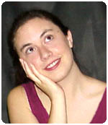
Think good thoughts
Each time you notice a bad thought, purposefully think of something that makes you happy or proud. Or memorize a poem, prayer, or quote and use it to replace a bad thought.

Breathing exercises

- Sit or lie down and uncross your legs and arms.
- Take in a deep breath. Then push out as much air as you can.
- Breathe in and out again, this time relaxing your muscles on purpose while breathing out.
- Keep breathing and relaxing for 5 to 20 minutes at a time.
- Do the breathing exercises at least once a day.

Self-massage
- Start with your left shoulder, massaging with your right hand.
- Move to your upper arm and gently but firmly knead the muscles in your biceps and triceps.

- Now go to your lower arm.
- Gently squeeze the muscles there.
- Now go to your wrist, firmly squeeze and press.
- Now massage the large muscle around your thumb.
- Go to the rest of your hand.
- Now your fingers.
- Do the other arm and hand.
Whatever method you choose to relax, practice it.
It takes practice to learn relaxation.
Healthy Stress

Now that you have learned some new healthy life skills, you may find that being healthy may be stressful. Healthy habits are hard to keep up. It can also be stressful when others resist the healthy choices you want for them. If you find yourself in these cases, here are some ways to relieve your stress:


Spending extra time in food preparation or grocery shopping
  - Ask a family member to help shop.
  - Make double recipes. Freeze part for later.

Feeling you cannot eat your favorite foods
  - Allow yourself to have your favorite foods in small amounts now and then.
  - Remind yourself how important preventing diabetes is to you.

Feeling upset your family doesn’t like low-fat foods
  - Ask your family to support your efforts to try new foods.
  - Discuss your feelings and your commitment to weight loss with your family. Discuss options with them. Then try one.
Feeling uncomfortable participating in social activities
  - Call the host ahead and ask what will be served
  - Bring a low-fat dish.
  - Before you go to a party, plan what foods you will choose.
  - Turn down invitations that are not important to you.

Feeling you cannot fit physical activity into an already busy schedule
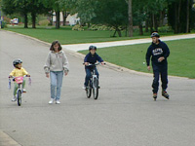
  - Make an appointment with yourself to be active.
  - Combine activity with other events you plan to do. Take a family walk to spend time together. Or walk with friends from the senior center.
From Diabetes Prevention Program http://www.bsc.gwu.edu/dpp/lifestyle/dpp_part.html
Web Resources
To find more information about stress check out these websites.

Medline Plus by the National Institutes of Health
www.nlm.nih.gov/medlineplus/stress.html

Description: General information about stress. User-friendly and informative. Available in Spanish.

Graduation
and
Strategies for
Healthy Living
What is in Graduation and Strategies for Healthy Living?

You are a Self-Manager………………………………………………..…………………….92
Keeping It Up!...............................……………………………………………..………..93
Rewarding Yourself .………94
Avoid Going Back to Your Old Habits…………………………..…..……………..…..96
Finding Support.………………..………………………………………………………….…..97
Live Well, Be Well…………………………………………………………………………....98
My Action Plan. ………99
Congratulations………………………………………………….……………………………101
You are a Self-Manager

Self-management is always a decision. You are the only person who can decide to take action or decide to do nothing about your health. By participating in the Live Well, Be Well project you took a very important step to manage your risk of getting diabetes. By making goals and action plans you are managing your pre-diabetes.

These are the steps you have learned to be an active self-manager:

- Decide what you want to accomplish.


- Look for new ways to accomplish this goal.

- Start making short-term plans by making an action plan.

- Follow your action plan.

- Check your progress.

- Make changes as needed.

- Remember to reward yourself.

Now that you have learned the basics of self-management keep it up!
From “Living A Healthy Life with Chronic Conditions” by Lorig, K; Holman, H; Sobel, D; et al.
Keeping It Up!
If you are having trouble staying motivated, don’t be surprised. Even the most dedicated have to be creative in motivating themselves to continue a healthy lifestyle. Here are some tips on maintaining your physical activity and healthy eating habits:

Challenge yourself. Don’t just do one action plan all of the time. Add some changes to it. For example if you started walking 10 minutes a day, keep adding 5 more minutes every week until you can do 30 minutes. Keep it interesting by challenging yourself a little more every time. But always make action plans achievable.

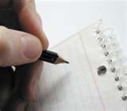
Chart your progress. This could mean marking your calendar on the days you exercised or writing down what you ate for the day. You will be surprised to see at the end of the month all what you have accomplished!

Bring a friend. Keep yourself responsible by walking or doing other exercises with a partner, friend, or pet.

Focus on a pleasant memory or activity. This might include inspiration from memories of spending time with your children or grand-children. You may also find inspiration from positive self-talk as you work out or decide what to eat.
What are you doing to keep up your changes?
Write it down here: ________________________________
Rewarding Yourself

Self-reward means prizing yourself when you reach an action plan or a goal. Rewards are also a great way to keep you motivated. They don’t have to be expensive. But they have to be meaningful. They should also reinforce your hard work.

Reward yourself for meeting action plans or short-term goals
Each day that you meet your daily goals
- Give yourself a pat on the back.
- Stick a note of praise on the dashboard of your car or on the bathroom mirror.


Reward yourself for meeting long-term goals
- If you meet a monthly goal, go to a movie with a friend.
- If you meet your long-term goal, plan a family outing or purchase a new outfit.

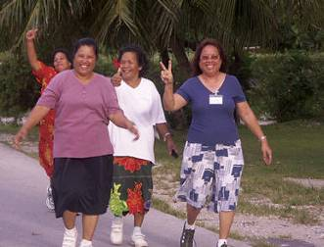
Reward yourself by reviewing how far you have come
- Think back to when you first started.
- Review how you solved your problems.
- Allow yourself to feel good about both large and small successes.

Reward yourself by bragging
- Tell your friends about the benefits you are experiencing.
- Encouraging others to get active can be a real self-reward.

How are you going to reward yourself next time when you achieve your action plan? Write it down here:
_____________________________________________________________________________________________________________________________________________
Avoiding Going Back to Your Old Habits

Most of us experience an interruption in our healthy eating or physical activity. That is OK. But do not let it turn into a reason to quit. When an interruption happens act immediately!

Avoid negative thoughts
Negative thinking tends to decrease motivation. Positive self-talk can help you find solutions to barriers and take action. It will make feel good about yourself.

Remind yourself of your goals for becoming healthy
Remember those important reasons why you joined Live Well, Be Well. Use them to remind you to stay healthy as a goal in your life.


Get help from friends or family members
Find someone who listens to you without judging you. Or someone who helps you to be active.

Finding Support

1. Identify what words or actions will help you feel supported
- Think about the kind of support that you want the most. Is it words of support, help, or someone to keep you company?
- Once you know the type of support you need and want, think about who can give it.


2. Identify the people that can support you
- Think about the people with whom you are most comfortable.
- You may choose help from friends, family, or neighbors.
- Or look for other resources in your community. For example, exercise instructors, senior centers, religious, groups, or health care organizations.

3. Communicate your needs to your support person
Only you know what will work for you. You need to tell your support person how they can support you. Communicate your needs using “I…”. Some examples are:
- “I want you to help me increase my exercise.”
- “I would like it if you help me cook once a week”
- “It would be helpful to me if you…”

Who is that one person who can give you the support you need?
Live Well, Be Well

Remember that diabetes can be prevented! Do the following 4 things to lower your risk of getting diabetes:

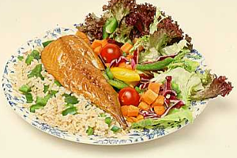
Eat Smart! It means eating foods that have vitamins, minerals and fiber such as vegetables, fruits, grains, nuts, beans, lean meats. Making healthier choices in your every day life can help you prevent diabetes.


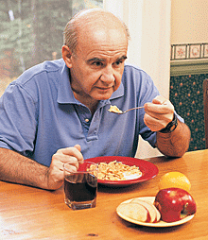
Eat Breakfast! Eating something in the morning will help you control your blood sugars, be more alert, and help you lose weight. Eat some kind of protein for breakfast and whole-grain and you will be off to a great start.

Eat your Colors! Fruits and vegetables may help to prevent diabetes because they are rich in fiber. Eat at least 5 colorful fruits and vegetables per day.

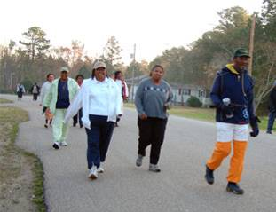
Get Active! Physical activity gives you many health benefits. One of them is lowering your risk of developing diabetes. When you exercise your body uses better your blood sugar. Work up your way to 30 minutes 5 days a week of physical activity.
My Action Plan

To lower your blood sugar level, you need an action plan to reach your goal.
- Choose the area you now want to work on for preventing diabetes.
4 Ways I Can Prevent Diabetes
Get active  □ | Eat smart  □ | Eat breakfast  □ | Eat your colors  □

- Be specific about what you will do!
By _____________________________(set a date)
I will (write the plan here):

- Then ask yourself, "On a scale of 1 to 10, how confident am I that I can do this by the next phone call?" If you answer 6 or less, think about picking an easier goal to get you started.
On a scale of 1 to 10, I am ______confident that I can do this.
What could make this hard to do? ____________________________
___________________________________________________
What can I do to overcome these barriers? ______________________
___________________________________________________
My Action Plan

To lower your blood sugar level, you need an action plan to reach your goal.
- Choose the area you now want to work on for preventing diabetes.
4 Ways I Can Prevent Diabetes
Get active  □ | Eat smart  □ | Eat breakfast  □ | Eat your colors  □

- Be specific about what you will do!
By _____________________________(set a date)
I will (write the plan here):

- Then ask yourself, "On a scale of 1 to 10, how confident am I that I can do this by the next phone call?" If you answer 6 or less, think about picking an easier goal to get you started.
On a scale of 1 to 10, I am ______confident that I can do this.
What could make this hard to do? ____________________________
___________________________________________________
What can I do to overcome these barriers? ______________________
___________________________________________________
Congratulations!


Congratulations you have completed the
Live Well, Be Well program. You did it! You made a commitment to health for yourself and your family. You also made changes in your life to prevent diabetes. Keep up your healthy eating habits and physical activity. Share what you learned with others. Keep this binder for future use or share it with a friend or family member.

